**Analysis of Vehicle Workshops in US.**

ABSTRACT: Data analysis is important in business to understand problems facing an organization, and to explore data in meaningful ways. Data in itself is merely facts and figures. Data analysis organizes, interprets, structures, and presents the data into useful information that provides context for the data. In this Research paper, we are taking data according to the months before the vehicle failure and the Km vehicle is already driven. Our main aim is to check practically After how many months vehicles start to give problems according to their States. And make a guess of how many accidents are happening in each State, And to solve the problem of shortage of Resources for Vehicles. The range of the correlation coefficient is from -1 to +1. If we are getting a correlation coefficient 0 then it means no relation and if negative, then trades are opposite meaning one is increasing and the other is decreasing or vice versa, and if positive then trades are similar. If we are getting correlation coefficient negative for any states then the vehicles in those states are not having any problem commonly or people are maintaining their vehicle properly but not using it often. If we get a strong relation between then maybe there are series problems for vehicles commonly such as Accidents, Resources for vehicles, etc. in that state. If there is no effect then that means vehicles in that state do not get any failure easily.

Introduction:Thefailure of the vehicle and the repair of vehicles happens all the time in our world. But it is important to find out which country is having how much vehicle failure happening in all sort of states to find out is there any problem in vehicles because of the same reason or the analysis for the vehicles company to hire more of their branches in those countries to increase their businesses. This can also give us information but environmental problems like accidents, resources for vehicles, etc. In this research paper, we are analyzing the vehicle failure of States in the US in the year 2020. We are analyzing data of states like California (CA), Florida (FL), Texas (TX), Los Angeles (LA), Arizona (AZ),Georgia (GA), North Carolina (NC).

Literature Reviews:

Data Visualization:

**Graph 1) Bar Plot of Failure of a vehicle in 1 and 2 months after their sell.**

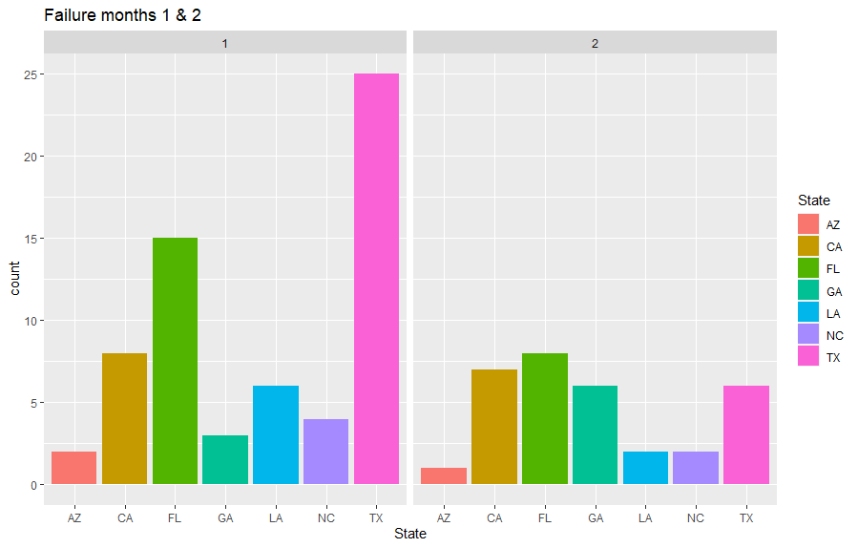**Graph 2) Box Plot of Vehicles according to the KM they are driven. 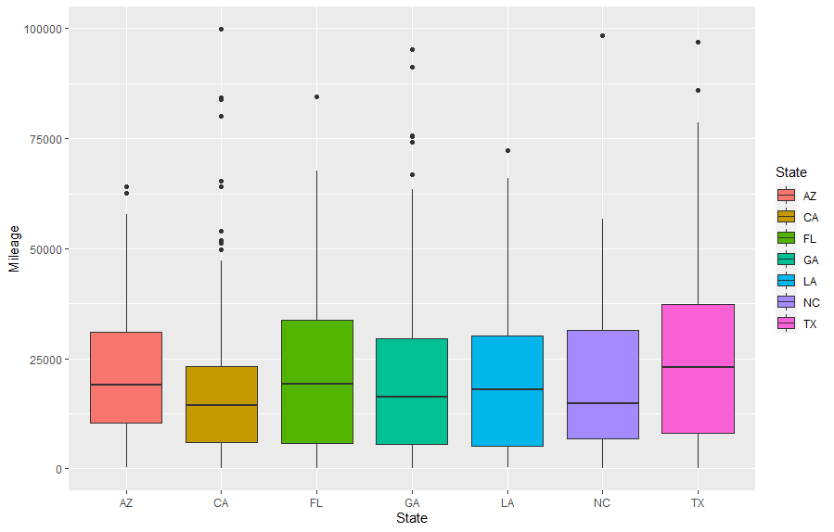Graph 3) Histogram of no. of Vehicles according to the KM they are driven.** 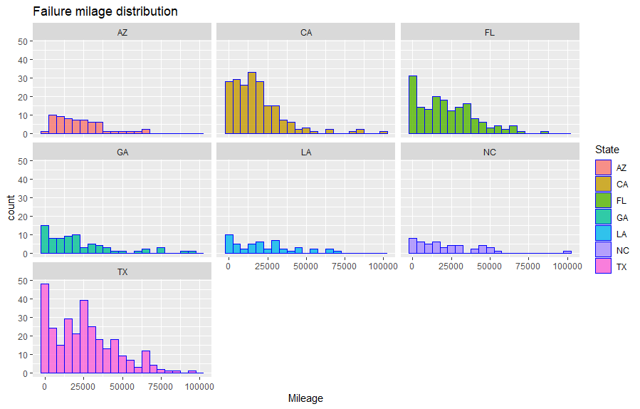

**Graph 4) Labor Hours VS Labor Cost.** 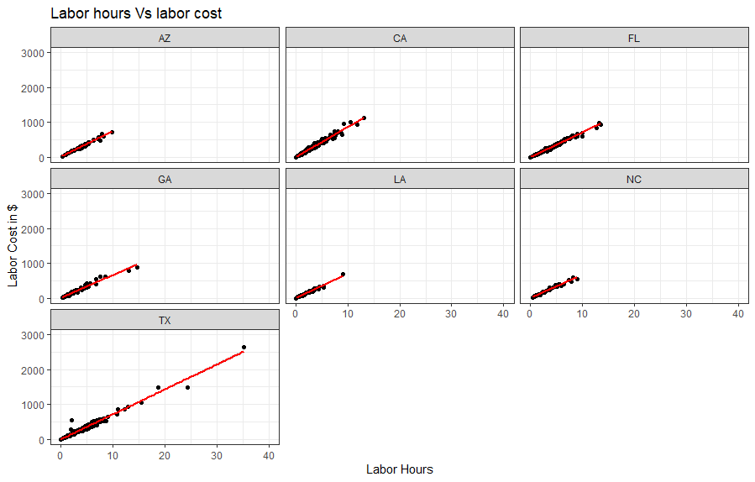

**Graph 5) Scatter Plot of Vehicles according to the KM they are driven and After how many Months they are being Repaired.**

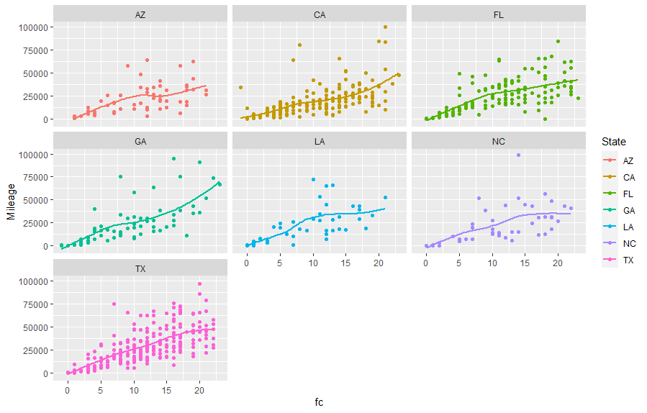

1. Arizona (AZ): In graph 1 there are not more vehicles got failure in their first and second months. But according to Graph 3, some vehicles are showing failure after 20000-25000 KM. In Graph 4 by looking at labor cost and labor hours we can say that these vehicles do not have major problems and by looking at Graph 5 (how many KM vehicles they have driven and the months after they are being repaired) everything is quite normal.
2. California (CA): In graph 1 there are more than 10 vehicles got failure in their first and second months. Graph 3 where it shows that there are more vehicles in between 0 KM to 50000 KM. And In Graph 4 we can see that these vehicles are having problems but they are getting solved in less cost and hours. In Graph 5 we can also see some vehicles are having problems after 10 months too.
3. Florida (FL): In graph 1 there are more than 15 vehicles got failure in their first and second months. Graph 3 where it shows that there are more vehicles in between 0 KM to 50000 KM too And in Graph 4 we can see that these vehicles are having problems but they are getting solved in less cost and hours. And in Graph 5 we can also see some vehicles are having problems after 10-20 months too
4. Georgia (GA): In graph 1 there are not more vehicles got failure in their first and second months. But In Graph 3 where it shows that there are more vehicles in between 0 KM to 50000 KM. In Graph 4 we can see that these vehicles are having problems but they are getting solved in less cost and hours. And in Graph 5 we can also see some vehicles are having problems after 1-10 months.
5. Los Angeles (LA): According to graph 1 there are not more vehicles got failure. According to Graph 3, there are not many vehicles having problems in between 0-50000 KM. By looking at Graph 4 labor cost and labor hours and by looking at Graph 5 (how many KM vehicles they have driven and the months after they are being repaired) condition in Los Angeles seems to be quite normal.
6. North Carolina (NC): According to graph 1 there are not more vehicles got failure. According to Graph 3, there are not many vehicles having problems in between 0-50000 KM. By looking at Graph 4 labor cost and labor hours and by looking at Graph 5 (how many KM vehicles they have driven and the months after they are being repaired) condition in Los Angeles seems to be quite normal.
7. Texas (TX): According to graph 1 there are more than 30 vehicles that are being reported in 1 & 2 months to get failure. Graph 3 show that there is too many vehicles failure in between 0 to 50000 KM. By looking at Graph 4 there are many vehicles with too-high cost and hour values. Other than this by looking at Graph 5 we can also see vehicles having problems in their 10-20 months of service.

CORRELATION ANALYSIS: If we are getting a correlation coefficient negative for any states then the vehicles in those states are not having any problem commonly or people are maintaining their vehicle properly but not using it often. If we get a strong relation between then maybe there are series problems for vehicles commonly such as Accidents, Resources for vehicles, etc. in that state. If there is no effect then that means vehicles in that state do not get any failure easily.

|  |  |
| --- | --- |
| **COUNTRY** | **1st CORRELATION ANALYSIS** |
| **Arizona (AZ)** | **0.5357142** |
| **California (CA)** | **0.7272187** |
| **Florida (FL)** | **0.7213759** |
| **Georgia (GA)** | **0.6076672** |
| **Los Angeles (LA)** | **0.4739348** |
| **North Carolina (NC)** | **0.6076672** |
| **Texas (TX)** | **0.7363761** |

Conclusion:

1. Arizona (AZ): **According to graph 1 there are not more vehicles got failure so that means there is not any problem with any vehicles which are being sold there, So it is safe to buy a new vehicle there or there is not any environmental problem out there in Arizona. But according to Graph 3, some vehicles are showing failure after 20000-25000 KM that means people there do not use vehicles often. And this can be proved after seeing Graph 4 and Graph 5. By looking at labor cost and labor hours we can say that these vehicles do not have major problems and by looking at how many KM vehicles they have driven and the months after they are being repaired condition in Arizona seems to be quite normal.**
2. California (CA): **In graph 1 there are more than 10 vehicles so that means some vehicle sellers there are not giving good quality first-hand vehicles This can be proved by looking at Graph 3 where it shows that there are more vehicles in between 0 KM to 50000 KM. In Graph 4 we can see that these vehicles are having problems bet they are getting solved in less cost and hours so we can say that it’s not any major problem. Other than these in Graph 5, we can also see there are vehicles which are having problems after 10 months too so we can also say that this can be an environmental problem or it can be nothing too.**
3. Florida (FA): **In graph 1 there are more than 15 vehicles got failure in their first and second months. That means some vehicle sellers there are not giving good quality first-hand vehicles Which can be proved by looking at Graph 3 where it shows that there are more vehicles in between 0 KM to 50000 KM too. In Graph 4 we can see that these vehicles are having problems bet they are getting solved in less cost and hours so we can say that it’s not any major problem. Other than these in Graph 5, we can also see there are vehicles which are having problems after 10 months too so we can also say that this can be an environmental problem or it can be nothing too.**
4. Georgia (GA): **In graph 1 there are not more vehicles got failure in their first and second months. But In Graph 3 where it shows that there are more vehicles in between 0 KM to 50000 KM So that can be mean people there do not drive vehicles more. In Graph 4 we can see that these vehicles are having problems but they are getting solved in less cost and hours so we can say that it’s not any major problem. And in Graph 5 we can also see some vehicles are having problems after 1-10 months more because people there may not drive much or there can be environmental problems.**
5. Los Angeles (LA): **According to graph 1 there are not more vehicles got failure so that means there is not any problem with any vehicles which are being sold there, so it is safe to buy a new vehicle there or there is not any environmental problem out there in Los Angeles. According to Graph 3, there are not many vehicles having problems in between 0-50000 KM that means people there do not use vehicles often or they maintain their vehicles very well. And this can be proved after seeing Graph 4 and Graph 5. By looking at labor cost and labor hours we can say that these vehicles do not have major problems and by looking at how many KM vehicles they have driven and the months after they are being repaired condition in Los Angeles seems to be quite normal.**
6. North Carolina (NC): **According to graph 1 there are not more vehicles got failure so that means there is not any problem with any vehicles which are being sold there, so it is safe to buy a new vehicle there or there is not any environmental problem out there in North Carolina. According to Graph 3, there are not many vehicles having problems in between 0-50000 KM that means people there do not use vehicles often or they maintain their vehicles very well. And this can be proved after seeing Graph 4 and Graph 5. By looking at labor cost and labor hours we can say that these vehicles do not have major problems and by looking at how many KM vehicles they have driven and the months after they are being repaired condition in North Carolina seems to be quite normal.**
7. Texas (TX): **According to graph 1 there are more than 30 vehicles that are being reported in 1 & 2 months to get failure which can be mean that vehicle sellers there are not giving good service. This can be proved by looking at Graph 3 which show that there is too many vehicles failure between 0 to 50000 KM. By looking at Graph 4 both types of vehicles show major problems and minor problems because they are having high labor and hour values. Other than this by looking at Graph 5, we can also conclude that there also vehicles having problems in their 10-20 months of service this can be mean that there can be also severe Environmental problems and it can also be mean that people there do not take care of vehicles.**

References:

1. [**Traffic Deaths, Driven Behavior, Seatbelt Laws, Pedestrian fatalities**](https://www.iii.org/fact-statistic/facts-statistics-highway-safety)
2. [**https://www.nhtsa.gov/press-releases/2020-fatality-data-show-increased-traffic-fatalities-during-pandemic**](https://www.nhtsa.gov/press-releases/2020-fatality-data-show-increased-traffic-fatalities-during-pandemic)